2022

PRESS RELEASE

TANTUM Barstool with steps at different levels

vitamin design has received further award from the world-renowned design prize iF DESIGN AWARD. The winning product, Barstool TANTUM, won in the discipline product, in the home furniture and decoration. Each year, the world’s oldest independent design organization, Han- nover-based iF International Forum Design GmbH, organizes the iF DESIGN AWARD.

Barstool TANTUM won over the 132-member jury, made up of independent experts from all over the world, with its steps at different levels. The competition was intense: almost 11,000 entries were submitted from 57 countries in hopes of receiving the seal of quality.

TANTUM - barstool with steps at different levels. The slender shape of the four slightly tilted legs provide stability combined with a comfortable seating experience. The solid wood is very pleasant to the feet and legs with its warm characteristics. Great for elevated seating at home or public spaces. The slanted legs give extra comfort to rest your legs on the different levelled footrests. Ideal for people of all heights and children to find comfortable seating. Available in natural treated solid wood: ash, beech, core beech, cherry, maple, oak, knotty oak, walnut, knotty walnut.
Design: GG DESIGNART

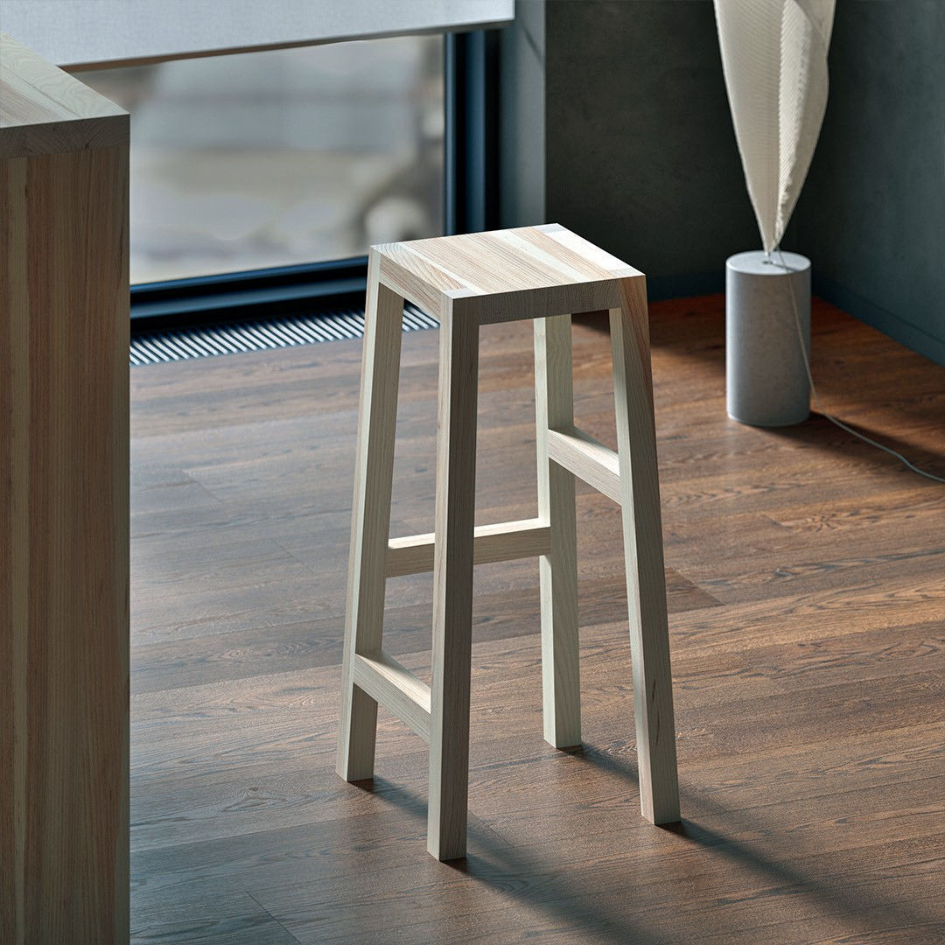
About the iF DESIGN AWARD

Since 1954, the iF DESIGN AWARD has been recognized as an arbiter of quality for excellent design. The iF De- sign brand is renowned worldwide for outstanding design services, and the iF DESIGN AWARD is one of the most important design prizes in the world. It honors design achievements in all disciplines: product, packaging, com- munication and service design, architecture and interior architecture as well as professional concept, user expe- rience (UX) and user interface (UI). All award-winning entries are featured on www.ifdesign.com and published in the iF Design App.

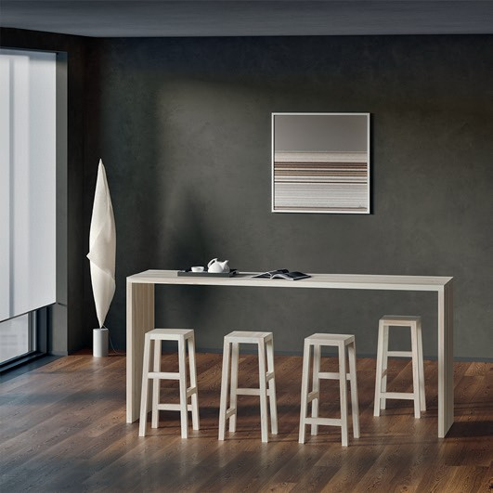
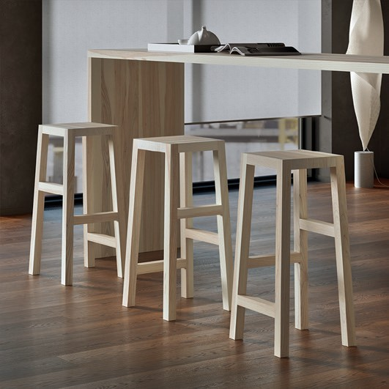
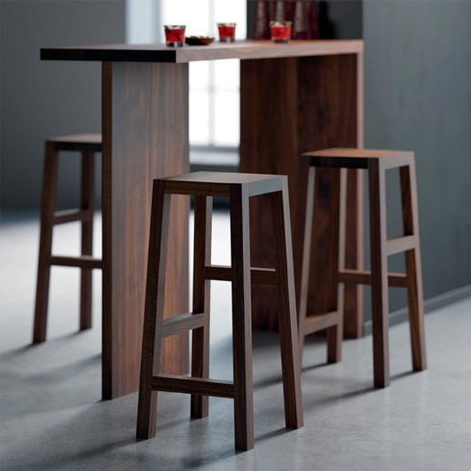
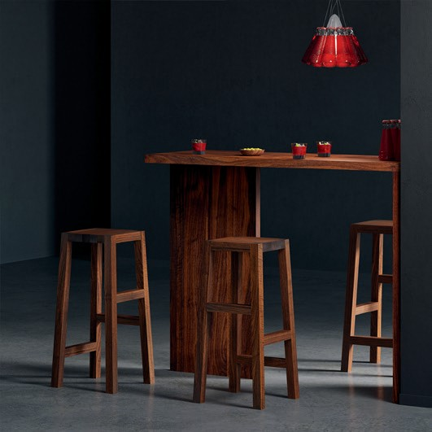

VITA - LIFE
MIN - MINIMALISM VITAMIN - HEALTH DESIGN - CREATION
vitamin design - nature friendly minimalistic design.

vitamin design was honored with the German Brand Award of the German Design Council for outstanding brand management.

SUSTAINABLE DESIGN FOR SUSTAINABLE FUTURE

Sustainable design is our design philosophy that seeks to maximize the environmental quality, while minimizing or eliminating negative impact to the natural environment.
The purpose of our designs is to create artifacts that benefit people.
Open your mind, go from your head to your heart, creating a sustainable future!

Digital network with vitamin design

The restructuring of all business units into digital processes is for every company an important topic with a huge potential. We offer a solution to implement individual content management with innovation, functionality and data integration. The consumer has the liberty to get the desired infor- mation at anytime and anywhere. All products and information are just a click away.

About vitamin design

vitamin design team designs and produces solid wood furniture with that certain something. Thanks to their up-to-date design the prospective classics from vitamin design are subtly presented based on ecological requirements and timeless modernity. Based on in-house and on close cooperation with selected manufacturers, vitamin design ensures his high performance and quality standards. Therefore the focus lies on flexibility, clear design and enhanced functionalities.

Press contact:
GG DESIGNART
Dona Handelsges. mbH Grosse Elbstrasse 40
22767 Hamburg, Germany
Phone: +49 (40) 31798362
info@vitamin-design.com
www.vitamin-design.com/press www.vitamin-design.com

